Higher Dimensions

Definition
# Source: AI Source: Provided by: [Data Path: Persons Table -> ID Column: 1, Name_En Column: Motasem Essam] -> From: [ChatGPT] on [7/20/2026]
Higher Dimensions refer to geometric spaces that have four or more independent dimensions. While one-, two-, and three-dimensional spaces can be visualized directly, higher-dimensional spaces are mathematical abstractions used to describe complex relationships, physical theories, and multidimensional data.
A higher-dimensional object requires more than three independent coordinates to specify the position of a point.

Purpose
# Source: AI Source: Provided by: [Data Path: Persons Table -> ID Column: 1, Name_En Column: Motasem Essam] -> From: [ChatGPT] on [7/20/2026]
Higher dimensions are used to:
- Extend geometric concepts beyond three-dimensional space.
- Model complex mathematical structures.
- Describe physical theories.
- Represent multidimensional datasets.
- Solve advanced engineering and scientific problems.
- Support computer science and artificial intelligence.

Understanding Higher Dimensions
# Source: AI Source: Provided by: [Data Path: Persons Table -> ID Column: 1, Name_En Column: Motasem Essam] -> From: [ChatGPT] on [7/20/2026]
Each additional dimension introduces a new independent direction.
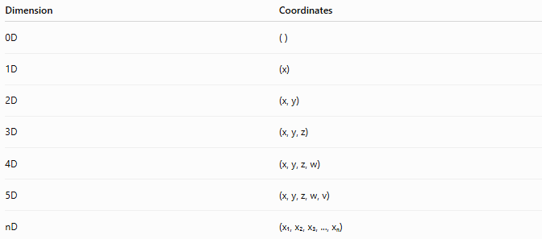
Dimension | Coordinates
0D | ( )
1D | (x)
2D | (x, y)
3D | (x, y, z)
4D | (x, y, z, w)
5D | (x, y, z, w, v)
nD | (x₁, x₂, x₃, ..., xₙ)

Four-Dimensional Space (4D)
# Source: AI Source: Provided by: [Data Path: Persons Table -> ID Column: 1, Name_En Column: Motasem Essam] -> From: [ChatGPT] on [7/20/2026]
A four-dimensional space has four independent directions.
A point is represented by:
$$\left(x , y , z , w\right)$$
where:
- x = first dimension
- y = second dimension
- z = third dimension
- w = fourth dimension
The fourth coordinate is mathematical and is not usually interpreted as physical space in elementary geometry.

Higher-Dimensional Objects
# Source: AI Source: Provided by: [Data Path: Persons Table -> ID Column: 1, Name_En Column: Motasem Essam] -> From: [ChatGPT] on [7/20/2026]
Examples include:
Tesseract (4D Hypercube)
The four-dimensional analogue of a cube.
Properties:
- 16 vertices
- 32 edges
- 24 square faces
- 8 cubic cells

4D Hypersphere
# Source: AI Source: Provided by: [Data Path: Persons Table -> ID Column: 1, Name_En Column: Motasem Essam] -> From: [ChatGPT] on [7/20/2026]
The four-dimensional analogue of a sphere.

Hypercube
# Source: AI Source: Provided by: [Data Path: Persons Table -> ID Column: 1, Name_En Column: Motasem Essam] -> From: [ChatGPT] on [7/20/2026]
The n-dimensional version of a cube.

Simplex
# Source: AI Source: Provided by: [Data Path: Persons Table -> ID Column: 1, Name_En Column: Motasem Essam] -> From: [ChatGPT] on [7/20/2026]
The higher-dimensional analogue of a triangle and tetrahedron.

Hyperplane
# Source: AI Source: Provided by: [Data Path: Persons Table -> ID Column: 1, Name_En Column: Motasem Essam] -> From: [ChatGPT] on [7/20/2026]
The higher-dimensional analogue of a plane.

Coordinate Representation
# Source: AI Source: Provided by: [Data Path: Persons Table -> ID Column: 1, Name_En Column: Motasem Essam] -> From: [ChatGPT] on [7/20/2026]
Higher-dimensional points are represented using multiple coordinates.
Example:
$$P=\left(2 , 5 , 1 , 4\right)$$
This point exists in four-dimensional space.

Measurements
# Source: AI Source: Provided by: [Data Path: Persons Table -> ID Column: 1, Name_En Column: Motasem Essam] -> From: [ChatGPT] on [7/20/2026]
Higher-dimensional geometry extends familiar concepts such as:
- Distance
- Angle
- Hypervolume
- Hyperarea
- Curvature
These measurements require generalized mathematical formulas.

Applications
# Source: AI Source: Provided by: [Data Path: Persons Table -> ID Column: 1, Name_En Column: Motasem Essam] -> From: [ChatGPT] on [7/20/2026]
Higher-dimensional geometry is used in:
- Advanced Mathematics
- Linear Algebra
- Topology
- Differential Geometry
- Physics
- General Relativity
- Quantum Mechanics
- Computer Science
- Machine Learning
- Artificial Intelligence
- Data Science
- Robotics
- Computer Graphics

Advantages
# Source: AI Source: Provided by: [Data Path: Persons Table -> ID Column: 1, Name_En Column: Motasem Essam] -> From: [ChatGPT] on [7/20/2026]
Higher-dimensional geometry:
- Models complex systems.
- Simplifies mathematical proofs.
- Represents multidimensional data.
- Supports optimization problems.
- Enables advanced scientific research.

Limitations
# Source: AI Source: Provided by: [Data Path: Persons Table -> ID Column: 1, Name_En Column: Motasem Essam] -> From: [ChatGPT] on [7/20/2026]
Higher-dimensional spaces:
- Cannot be directly visualized by humans.
- Require advanced mathematics.
- Often rely on computer visualization.
- Become increasingly difficult to interpret as dimensions increase.

Comparison with Lower Dimensions
# Source: AI Source: Provided by: [Data Path: Persons Table -> ID Column: 1, Name_En Column: Motasem Essam] -> From: [ChatGPT] on [7/20/2026]
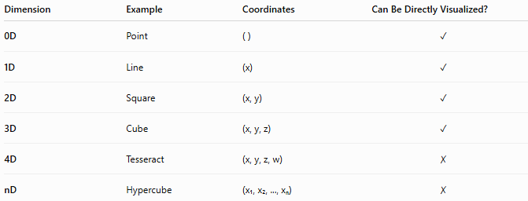
Dimension | Example | Coordinates | Can Be Directly Visualized?
0D | Point | ( ) | ✓
1D | Line | (x) | ✓
2D | Square | (x, y) | ✓
3D | Cube | (x, y, z) | ✓
4D | Tesseract | (x, y, z, w) | ✗
nD | Hypercube | (x₁, x₂, ..., xₙ) | ✗

Key Points
# Source: AI Source: Provided by: [Data Path: Persons Table -> ID Column: 1, Name_En Column: Motasem Essam] -> From: [ChatGPT] on [7/20/2026]
- Higher Dimensions are spaces with four or more independent dimensions.
- A point in four-dimensional space is written as:
$$\left(x , y , z , w\right)$$
- Common higher-dimensional objects include:
  - Tesseract
  - Hypercube
  - Hypersphere
  - Simplex
- Higher-dimensional geometry is essential in advanced mathematics, physics, computer science, artificial intelligence, and data analysis.

Conclusion
# Source: AI Source: Provided by: [Data Path: Persons Table -> ID Column: 1, Name_En Column: Motasem Essam] -> From: [ChatGPT] on [7/20/2026]
Higher Dimensions (4D and Beyond) extend the concepts of classical geometry into spaces with four or more independent directions. Although these spaces cannot be directly visualized, they provide powerful mathematical frameworks for describing complex structures, physical theories, and multidimensional data. Higher-dimensional geometry is fundamental to advanced mathematics, theoretical physics, computer science, machine learning, artificial intelligence, robotics, and scientific research, enabling the analysis and modeling of problems far beyond ordinary three-dimensional space.

